Expressions of Interest

Provision of farm land or a dam for the disposal of development water from Port Campbell’s new production bore

Introduction

Wannon Water’s Port Campbell borefield consists of one production bore which was drilled on site at the Port Campbell Water Treatment Plant (WTP) on Lord Street in 1996.
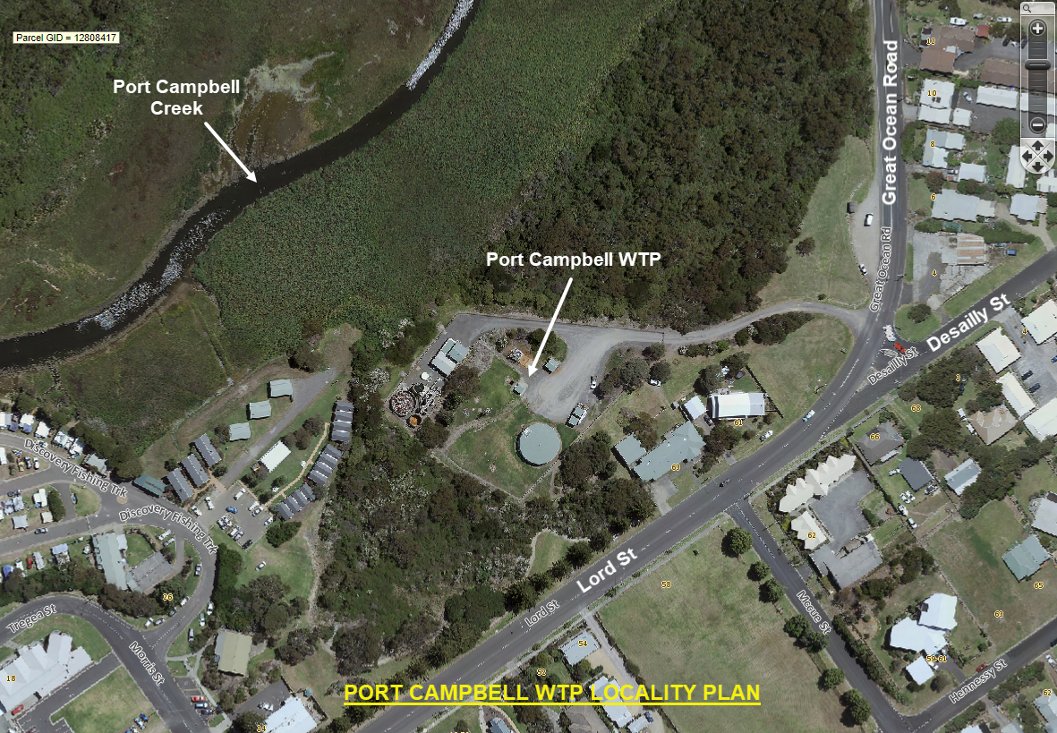
It provides groundwater which is treated and then distributed to the towns of Port Campbell, Timboon, and Peterborough. The supply network will soon expand to connect to the 12 Apostles Visitor Centre.
The bore is now at least half-way through its expected lifespan. To provide additional security of supply, we are planning to install a second production bore on site at the WTP.
We are currently working through a number of key planning tasks, including options for the disposal of development water during the construction phase.

Disposal options for development water

During the final construction phase, the bore is “developed” - a process that removes groundwater and natural sediment from the bore. During this process the groundwater is initially turbid and silty, but will become less turbid over time until it runs clear.
We expect that around 11 megalitres of development water will need to be disposed over a one to two week period. The development water is expected to be silty, above 30⁰C in temperature and have a salinity level around 300 mg/L TDS.
We are evaluating a number of options to dispose the development water - one of which is to send the development water to nearby farm land or a farm dam for disposal through a temporary pipeline or using a water tanker.
Disposal on the property may include storage of the water in a dam or land depression for settling, cooling and/or evaporation, then farm use such as irrigation, etc.
The construction of the bore is expected to occur in the summer.
We are therefore seeking Expressions of Interest from private land owners for the provision of farm land or a dam near the Port Campbell WTP for the disposal of development water.
Enquiries

Please direct all enquiries to Brendan Thian on 0409 238 299 or via email brendan.thian@wannonwater.com.au
Expressions of Interest form

Contact details

Name:
Address:
Phone:
Email:
ABN (if applicable):

Expression of Interest details

Property distance from the Port Campbell WTP:

Dam/land depression capacity:

Planned end use for water:

Charge per megalitre of water accepted:

Closing date:

To submit an Expression of Interest, please email this form to info@wannonwater.com.au by close of business on Wednesday 3 June 2020.

